
Services:
Services: All mains. Oil fired central heating

Parking: For 4 cars

Category & Tenure: Freehold and Entitled

Image 2:

Image 3:

Images 4:

Images 5:

Image 6:

Image 7:

Image 8:

Image 9:

Image 10:

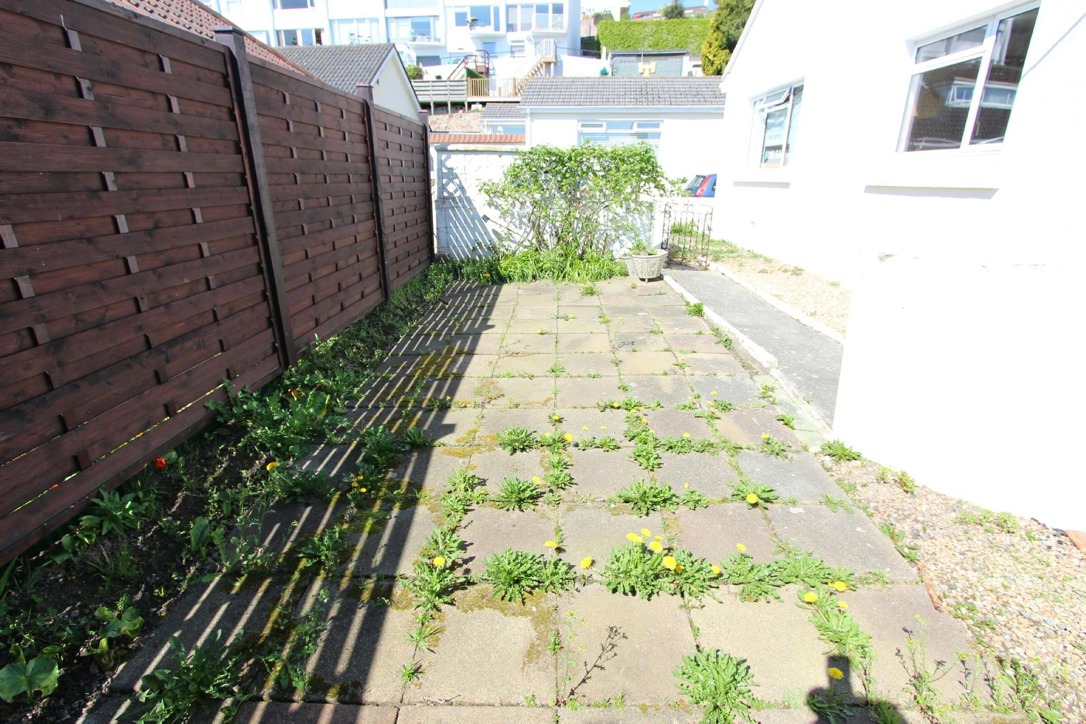

Image 11:

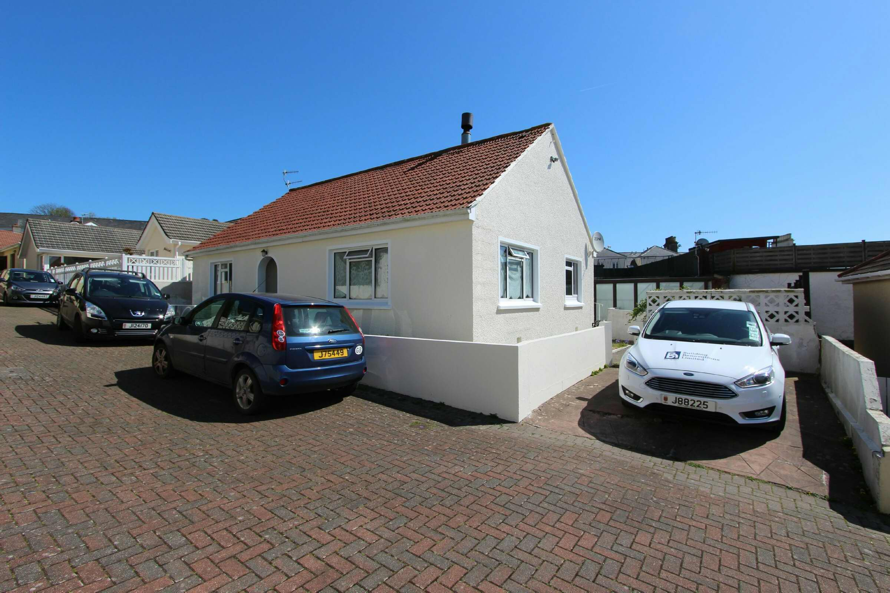

Image 12:

Image 13:

Image 14:

Image 15:

Image 16:

Image 17:

Image 18:

Image 19:

Image 20:

Image 21:

PLEASE NOTE:
Disclaimer: The agent has not tested any apparatus, equipment, fixtures and fittings or services and so cannot verify that they are in working order or fit for purpose. A buyer is advised to obtain verification from their advocate or surveyor. References to the tenure of a property are based on information supplied by the seller. The agent has not had sight of the title documents. A buyer is advised to obtain verification from their advocate. Items shown in photographs are not included unless specifically mentioned within the sales particulars. They may however be available by separate negotiation. An inventory of the contents to be included in the transaction, will be compiled once the sale is agreed. Buyers must check the availability of any property and make an appointment to view before embarking on any journey to see a property. All measurements are approximate.

All viewings to be conducted through Hunt Estates. Tel: 01534 860650

Rosewood
8 Manor Court
Undercliffe Road
JE2 3PS
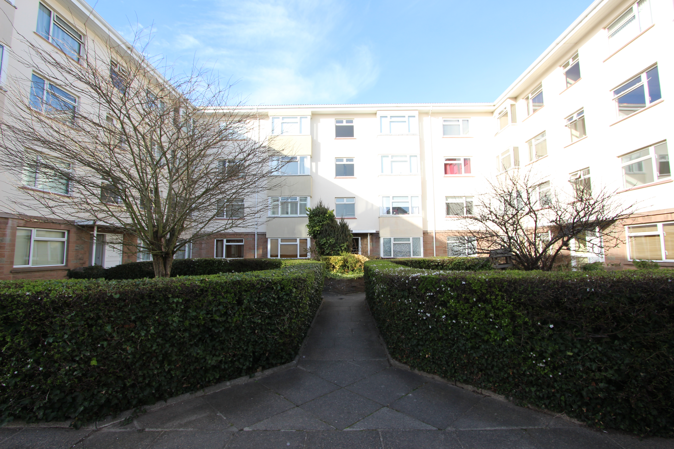
St. Helier

1 bedroom apartment at Marett Court
This bright and spacious purpose-built apartment is offered in immaculate condition throughout.

Situated in the popular development of Marett Court and is close to the beach and restaurants at Havre des Pas, local amenities, and a short walk to the town centre. This apartment would make an ideal step on the property ladder or a fantastic investment opportunity.

The apartment briefly comprises; Entrance hall, large lounge/diner, fully fitted kitchen, large double bedroom, house bathroom and internal store cupboard. Externally there are well kept communal gardens.

Viewing is highly recommended by Vendor's sole agent.

£235,000
Freehold

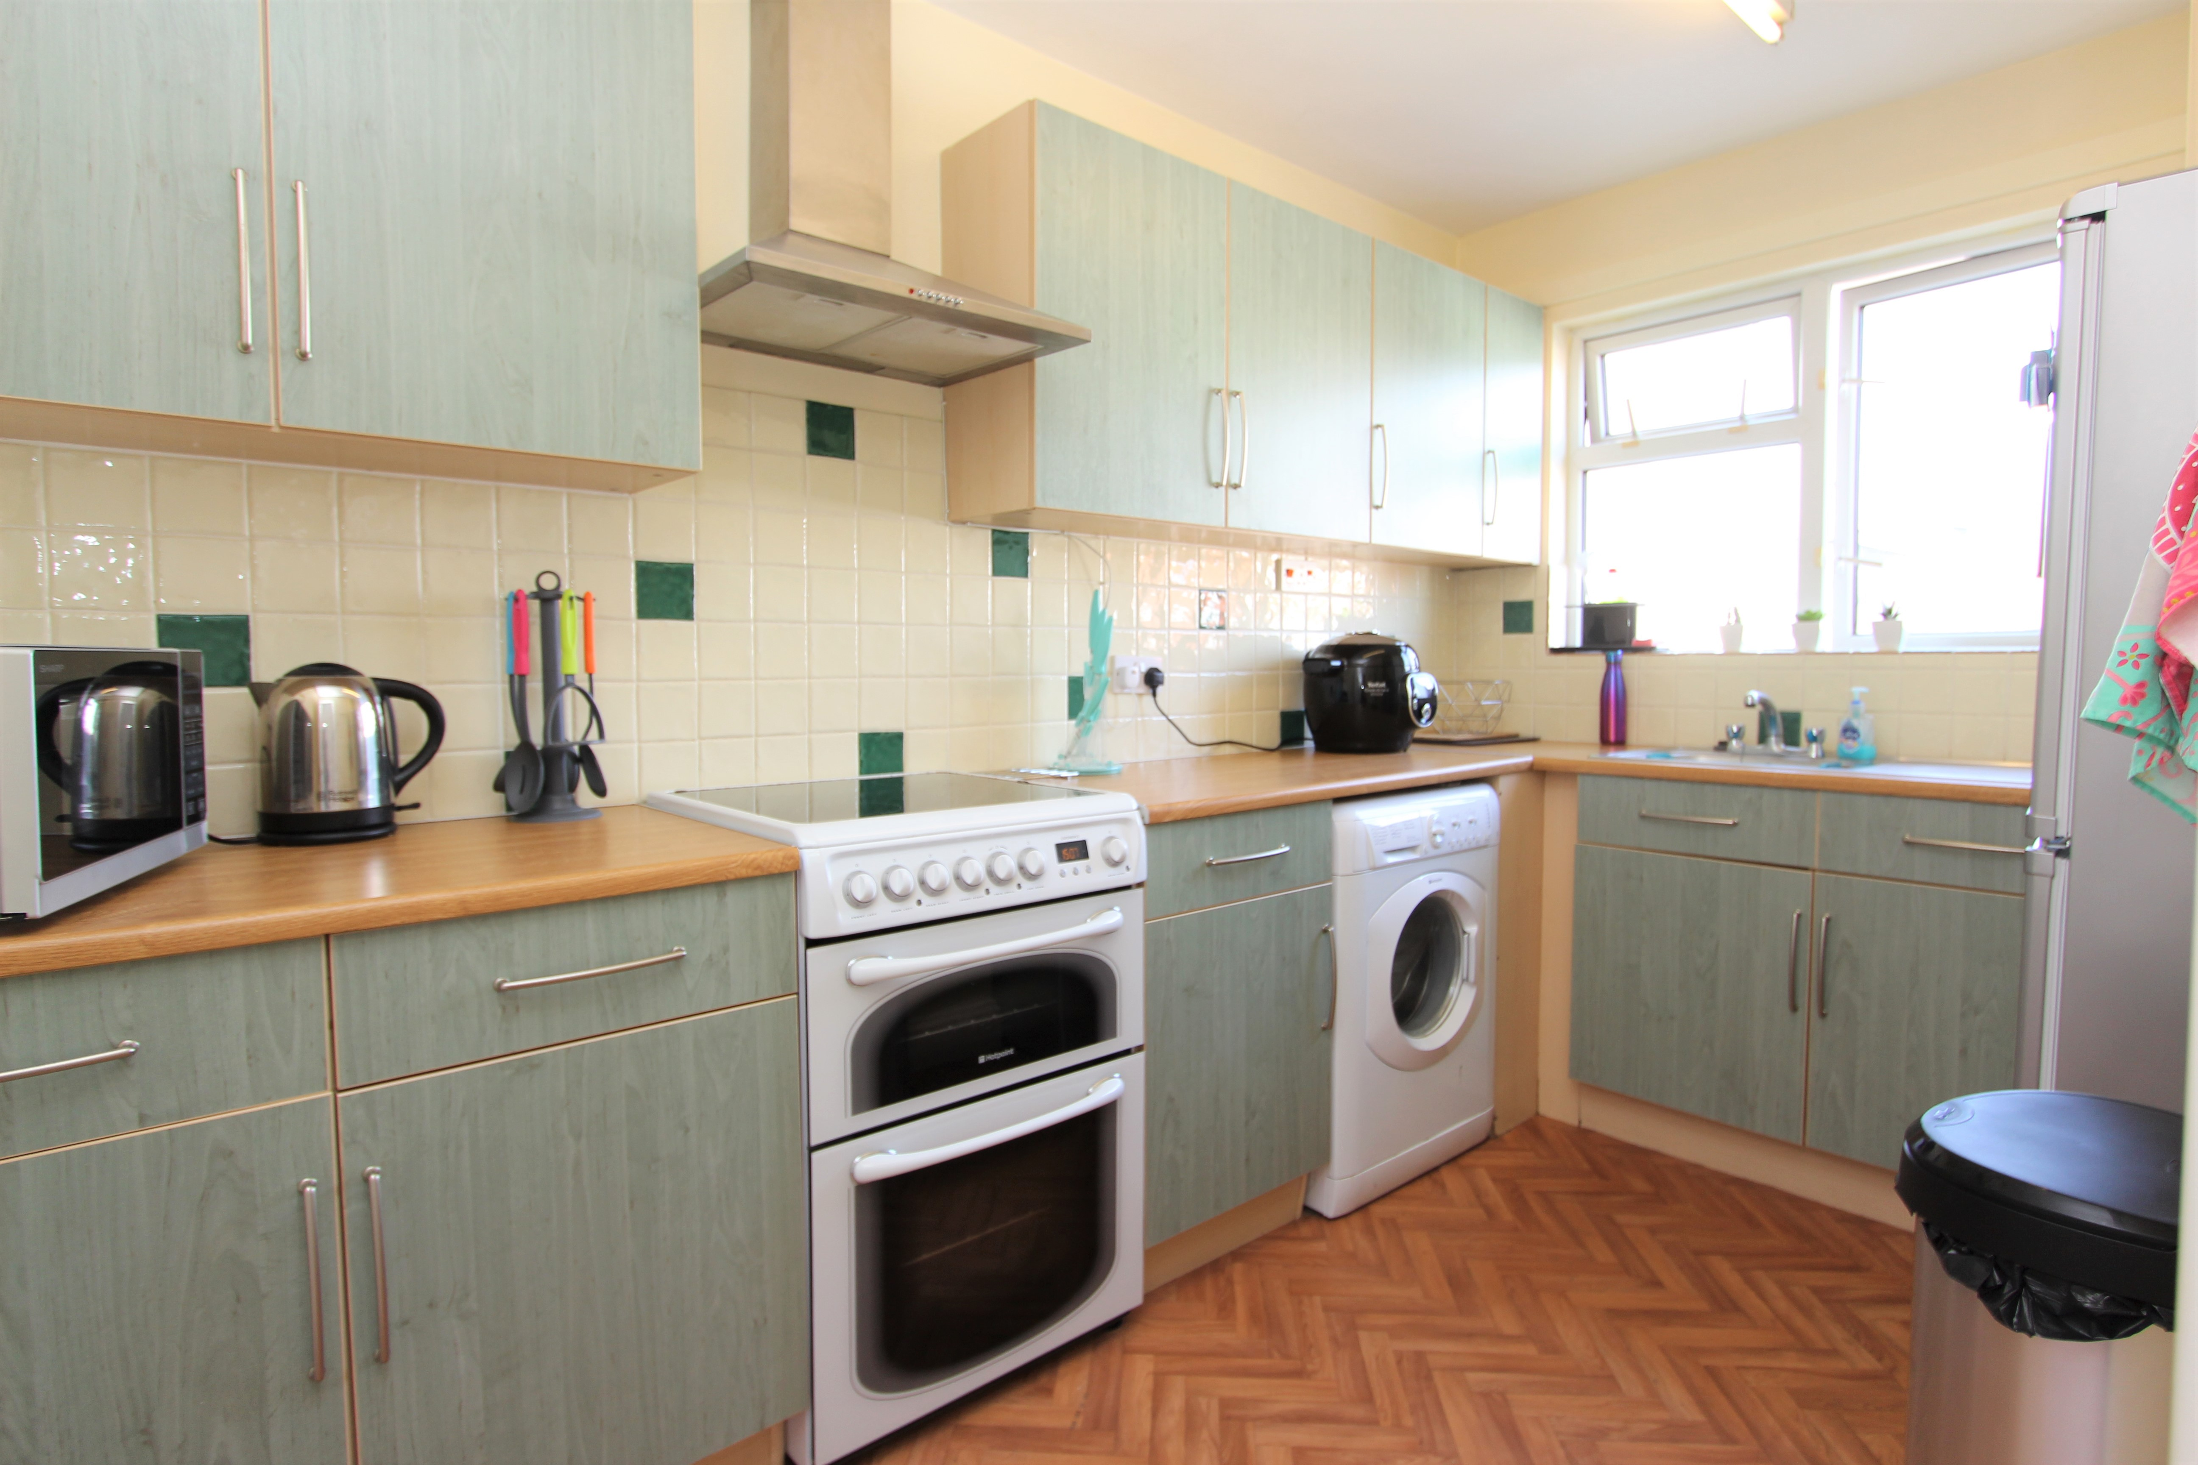
Bright and spacious 1 bedroom apartment
Immaculate throughout
Purpose built
Communal gardens
Close to the beach
Short walk to town centre

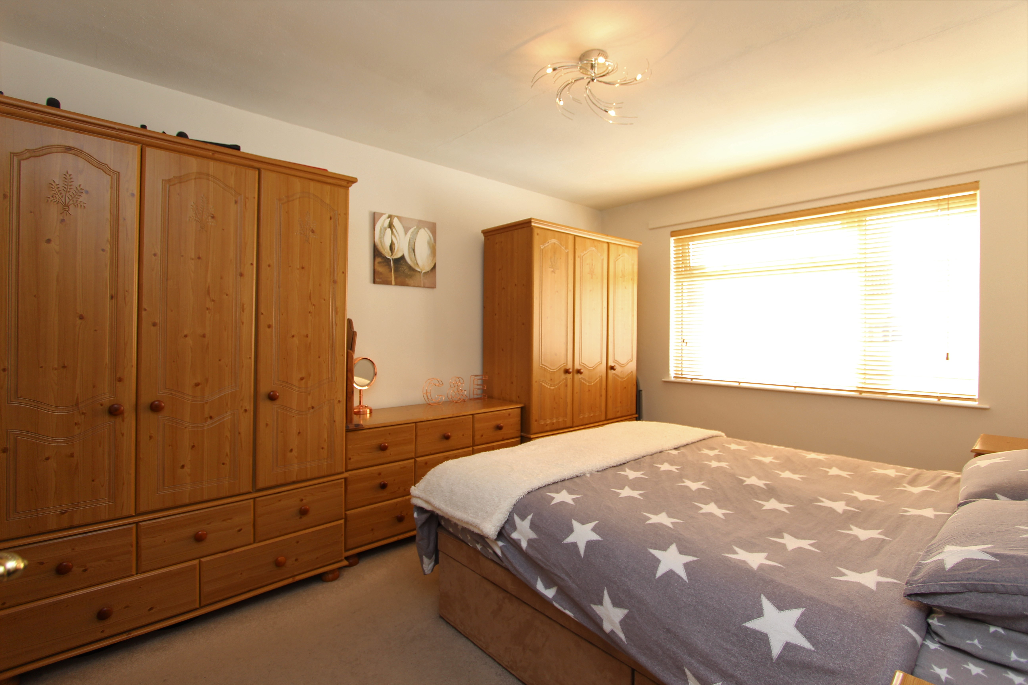
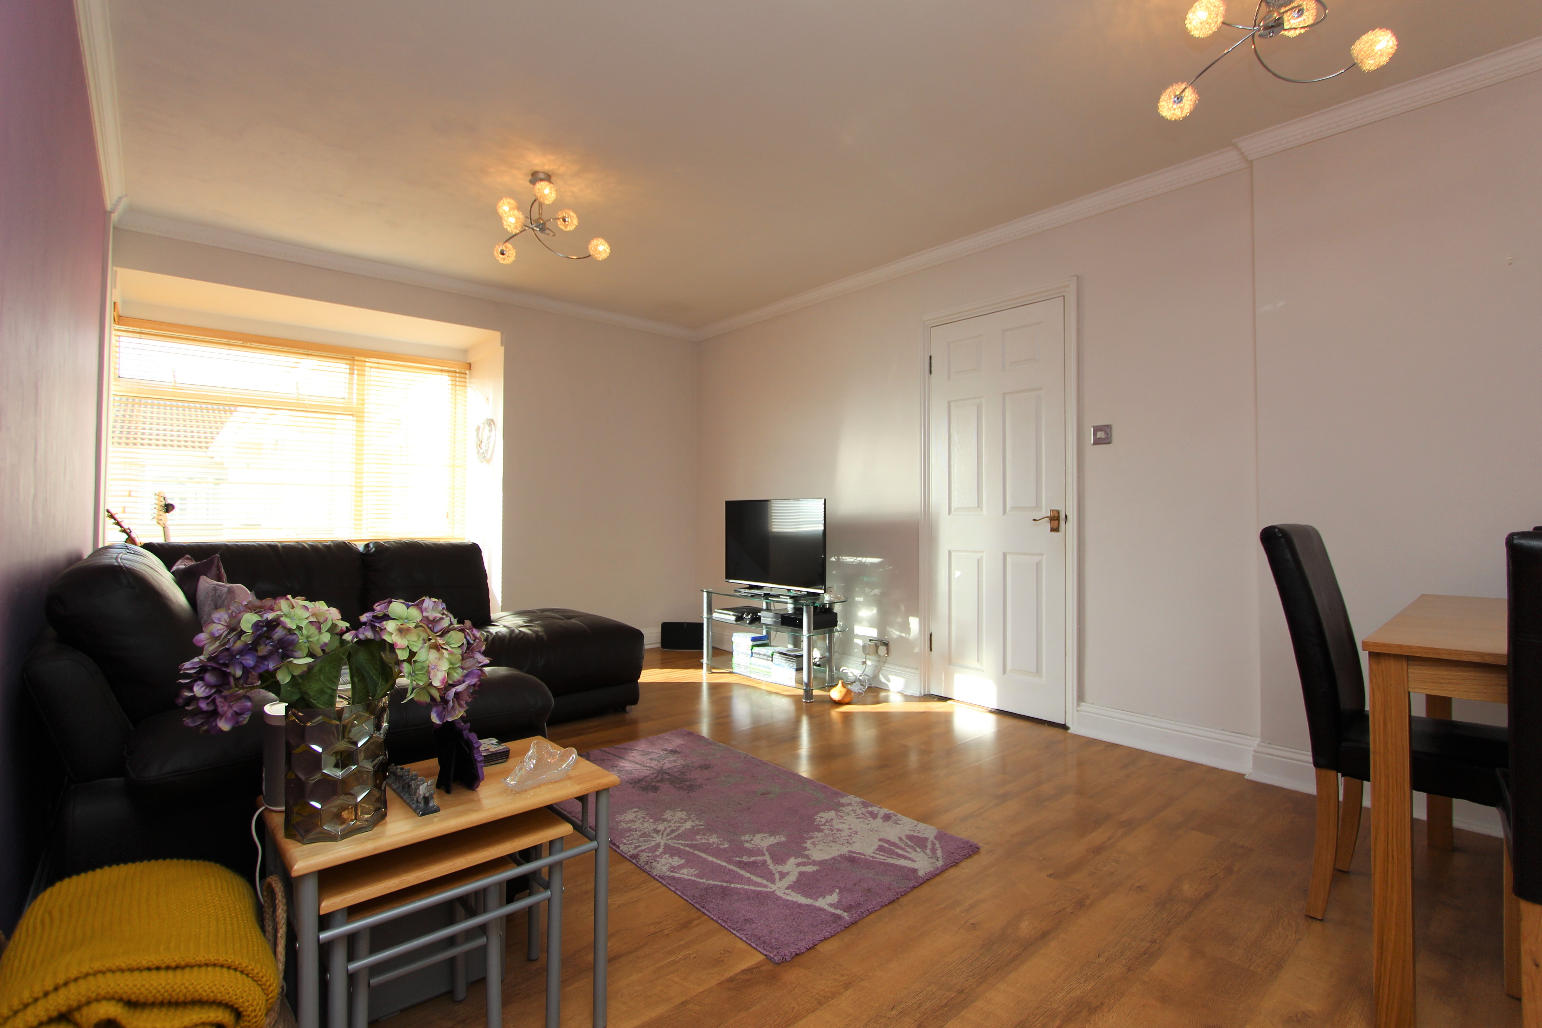
SERVICES

All mains except gas. Fully double glazed.

Service Charge: £213.00 per quarter.

Category and Tenure: Entitled - Flying Freehold

Parking: Rented parking available in secure underground garage
£105.06 pcm.



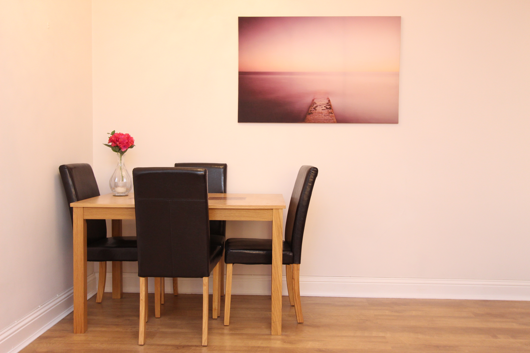
Disclaimer: The agent has not tested any apparatus, equipment, fixtures and fittings or services and so cannot verify that they are in working order or fit for purpose. A buyer is advised to obtain verification from their advocate or surveyor. References to the tenure of a property are based on information supplied by the seller. The agent has not had sight of the title documents. A buyer is advised to obtain verification from their advocate. Items shown in photographs are not included unless specifically mentioned within the sales particulars. They may however be available by separate negotiation. An inventory of the contents to be included in the transaction, will be compiled once the sale is agreed. Buyers must check the availability of any property and make an appointment to view before embarking on any journey to see a property. All measurements are approximate.

All viewings to be conducted through Hunt Estates. Tel: 01534 860650
ADDRESS
9 New Street
St Helier
Jersey
JE2 3RA

CONTACT US
E enquiries@huntestates.co
T 01534 860 650
W www.huntestates.co




